
American International University- Bangladesh (AIUB)
Faculty of Engineering (FE)

Course Name: | DATA COMMUNICATION | Course Code: | COE3103
Semester: | Spring 2024-25 | Section: | L
Faculty: | DR. AMIRUL ISLAM | Group: | 05

Experiment No: | 01
Experiment Name: | Introduction to MATLAB
Submitted by (NAME): | Afnan Bin Islam Nahin | Student ID: | 22-49350-3

Group Members |  | Name | ID
 | 1. | Afnan Bin Islam Nahin | 22-49350-3
 | 2. | Farhin Zahra | 22-46829-1
 | 3. | MD. Mehedi Hasan Anik | 22-48937-3
 | 4. | Sadikul Islam
 | 5. | Shah Rahat Hossain
 | 6.
 | 7.

Performance Date: | 3/3/25 | Due Date: | 17/3/25

Marking Rubrics (to be filled by Lab Instructor)
Category | Proficient [6] | Good  [4] | Acceptable [2] | Unacceptable [1] | Secured Marks
Theoretical  Background, Methods  & procedures sections | All information, measures and variables are provided and explained. | All Information provided is sufficient, but more explanation is needed. | Most information is correct, but some information may be missing or inaccurate. | Much information is missing and/or inaccurate.
Results | All of the criteria are met; results are described clearly and accurately; | Most criteria are met, but there may be some lack of clarity and/or incorrect information. | Experimental results don’t match exactly with the theoretical values and/or analysis is unclear. | Experimental results are missing or incorrect;
Discussion | Demonstrates thorough and sophisticated understanding.  Conclusions drawn are  appropriate for analyses; | Hypotheses are clearly stated, but some concluding statements not supported by data or data not well integrated. | Some hypotheses missing or misstated; conclusions not supported by data. | Conclusions don’t match hypotheses, not supported by data; no integration of data from different sources.
General formatting | Title page, placement of figures and figure captions, and other formatting issues all correct. | Minor errors in formatting. | Major errors and/or missing information. | Not proper style in text.
Writing & organization | Writing is strong and easy to understand; ideas are fully elaborated and connected; effective transitions between sentences; no typographic, spelling, or grammatical errors. | Writing is clear and easy to understand; ideas are connected; effective transitions between sentences; minor typographic, spelling, or grammatical errors. | Most of the required criteria are met, but some lack of clarity, typographic, spelling, or grammatical errors are present. | Very unclear, many errors.
Comments: |  |  |  | Total Marks (Out of 30):

Title: Introduction to MATLAB

Abstract:
This experiment, titled "Introduction to MATLAB," aims to familiarize students with MATLAB’s fundamental concepts, including signal generation, visualization, and manipulation. The experiment involves generating and plotting sinusoidal signals with different amplitudes and frequencies, using MATLAB’s built-in functions for mathematical computations and graphical representation. Multiple plots are displayed within a single figure using the subplot function, demonstrating the ability to analyze multiple signals simultaneously. Additionally, textual annotations are incorporated into plots for enhanced clarity. By summing two generated signals, the experiment further explores vectorized operations, a core feature of MATLAB’s computational efficiency. Through these exercises, students gain hands-on experience with essential MATLAB functions such as plot, axis, legend, and text, reinforcing their understanding of MATLAB as a powerful tool for scientific computing and signal processing.

Introduction:
MATLAB (Matrix Laboratory) is a high-level programming environment widely used for numerical computing, data analysis, and visualization. It provides an intuitive interface for mathematical operations, making it an essential tool for engineers, scientists, and researchers. This experiment, "Introduction to MATLAB," aims to introduce fundamental MATLAB concepts, including signal generation, plotting, and manipulation.

In this experiment, sinusoidal signals with different amplitudes and frequencies are generated and visualized using MATLAB’s built-in functions. By employing the `subplot` function, multiple signals are displayed within a single figure, enabling a comparative analysis. Additionally, MATLAB’s ability to annotate graphs with text enhances the clarity and interpretability of results. The experiment also explores vectorized operations by summing two signals, demonstrating MATLAB’s computational efficiency.

By completing this experiment, students will gain hands-on experience with essential MATLAB functions such as `plot`, `axis`, `legend`, and `text`. These foundational skills will provide a strong basis for future applications in scientific computing, signal processing, and engineering problem-solving.

Performance Task:

My ID: 22-49350-3

A=2
B=2
C=4
D=9
E=3
F=5
G=0
H=3

Therefore , values are

a1=F+1=6
a2=G+2=2
f1=E+1=4
f2=G+2=2

*Generate two signals with different amplitudes and phases as,
s1(t) = a1*cos(2*pi*f1*t),
s2(t) = a2*sin(2*pi*f2*t),

- Plot two curves on a single graph, assigning distinct labels for the title, x-axis, and y-axis. Additionally, specify unique colors, line styles, and markers for each curve. Use the axis command to customize the axis limits and scaling as needed.

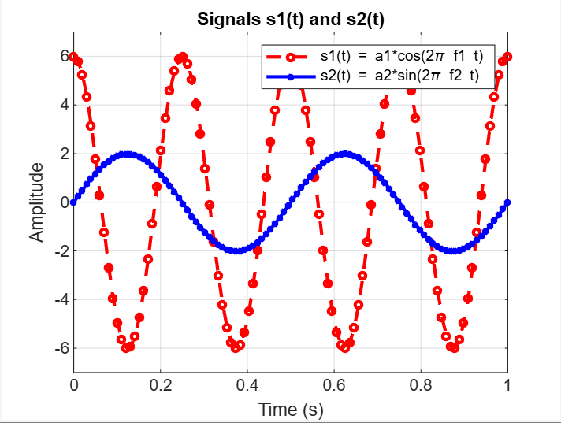
clc; clear; close all;

F = 5; E = 3; G = 0;
a1 = F + 1;
a2 = G + 2;
f1 = E + 1;
f2 = G + 2;

t = linspace(0, 1, 100);

s1 = a1 * cos(2 * pi * f1 * t);
s2 = a2 * sin(2 * pi * f2* t);

figure;
plot(t, s1, 'r--o', 'LineWidth', 2, 'MarkerSize', 4);
hold on;
plot(t, s2, 'b-*', 'LineWidth', 2, 'MarkerSize', 4);
hold off;

xlabel('Time (s)');
ylabel('Amplitude');
title('Signals s1(t) and s2(t)');
legend('s1(t) = a1*cos(2\pi f1 t)', 's2(t) = a2*sin(2\pi f2 t)');
axis([0 1 -max(a1, a2)-1 max(a1, a2)+1]);
grid on;

(b) Print a text inside the plot “This a test plot of Experiment 1 of Name and ID”

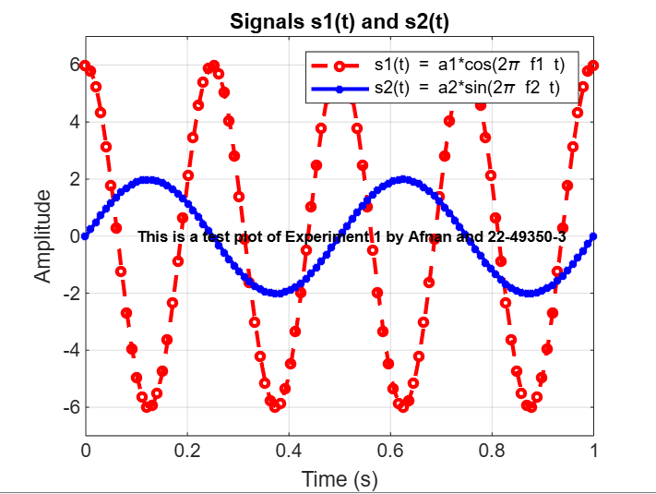clc; clear; close all;

F = 5; E = 3; G = 0;
a1 = F + 1;
a2 = G + 2;
f1 = E + 1;
f2 = G + 2;
t = linspace(0, 1, 100);

s1 = a1 * cos(2 * pi * f1 * t);
s2 = a2 * sin(2 * pi * f2 * t);

figure;
plot(t, s1, 'r--o', 'LineWidth', 2, 'MarkerSize', 4);
hold on;
plot(t, s2, 'b-*', 'LineWidth', 2, 'MarkerSize', 4);
hold off;

xlabel('Time (s)');
ylabel('Amplitude');
title('Signals s1(t) and s2(t)');
legend('s1(t) = a1*cos(2\pi f1 t)', 's2(t) = a2*sin(2\pi f2 t)');

axis([0 1 -max(a1, a2)-1 max(a1, a2)+1]);
grid on;

text(0.1, 0, 'This is a test plot of Experiment 1 by Afnan and 22-49350-3', 'FontSize', 8, 'FontWeight', 'bold', 'Color', 'black');

(c) Use subplot(3,1,1) and subplot(3,1,2) to make a three-panel subplot that puts both of these plots on the same window. See help subplot if needed

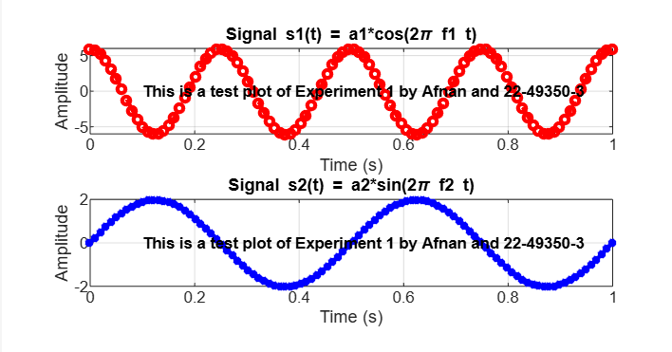
clc; clear; close all;
F = 5; E = 3; G = 0;
a1 = F + 1;
a2 = G + 2;
f1 = E + 1;
f2 = G + 2;
t = linspace(0, 1, 100);

s1 = a1 * cos(2 * pi * f1 * t);
s2 = a2 * sin(2 * pi * f2 * t);
figure;
subplot(3,1,1);
plot(t, s1, 'r--o', 'LineWidth', 2, 'MarkerSize', 4);
xlabel('Time (s)');
ylabel('Amplitude');
title('Signal s1(t) = a1*cos(2\pi f1 t)');
text(0.1, 0, 'This is a test plot of Experiment 1 by Afnan and 22-49350-3', 'FontSize', 8, 'FontWeight', 'bold', 'Color', 'black');

grid on;
subplot(3,1,2);
plot(t, s2, 'b-*', 'LineWidth', 2, 'MarkerSize', 4);
xlabel('Time (s)');
ylabel('Amplitude');
title('Signal s2(t) = a2*sin(2\pi f2 t)');
text(0.1, 0, 'This is a test plot of Experiment 1 by Afnan and 22-49350-3', 'FontSize', 8, 'FontWeight', 'bold', 'Color', 'black');

grid on;

(d) Create a third sinusoid as the sum: s3(t) = s1(t) + s2(t). In Matlab this amounts to summing the vectors that hold the samples of each sinusoid. Make a plot of s3 (t) over the same range of time as used in the previous two plots. Include this as the third panel in the window by using subplot (3,1,3).

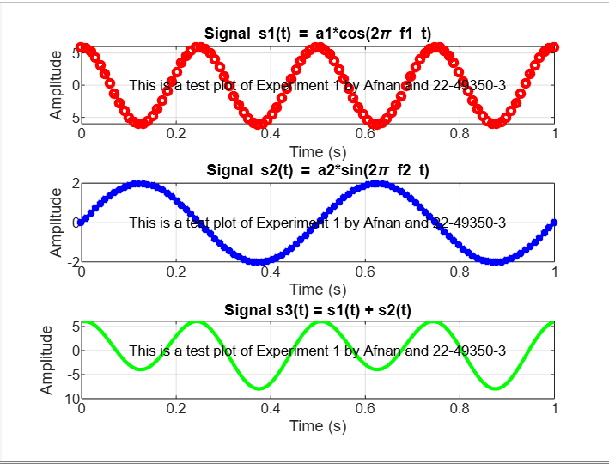
clc; clear; close all;
F = 5; E = 3; G = 0;
a1 = F + 1;
a2 = G + 2;
f1 = E + 1;
f2 = G + 2;

t = linspace(0, 1, 100);
s1 = a1 * cos(2 * pi * f1 * t);
s2 = a2 * sin(2 * pi * f2 * t);
s3 = s1 + s2;
figure;
subplot(3,1,1);
plot(t, s1, 'r--o', 'LineWidth', 2, 'MarkerSize', 4);
xlabel('Time (s)');
ylabel('Amplitude');
title('Signal s1(t) = a1*cos(2\pi f1 t)');
text(0.1, 0, 'This is a test plot of Experiment 1 by Afnan and 22-49350-3', 'FontSize', 8, 'FontWeight', 'normal', 'Color', 'black');
grid on;
subplot(3,1,2);
plot(t, s2, 'b-*', 'LineWidth', 2, 'MarkerSize', 4);
xlabel('Time (s)');
ylabel('Amplitude');
title('Signal s2(t) = a2*sin(2\pi f2 t)');text(0.1, 0, 'This is a test plot of Experiment 1 by Afnan and 22-49350-3', 'FontSize', 8, 'FontWeight', 'normal', 'Color', 'black');
grid on;
subplot(3,1,3);
plot(t, s3, 'g-', 'LineWidth', 2);
xlabel('Time (s)');
ylabel('Amplitude');
title('Signal s3(t) = s1(t) + s2(t)');
text(0.1, 0, 'This is a test plot of Experiment 1 by Afnan and 22-49350-3', 'FontSize', 8, 'FontWeight', 'normal', 'Color', 'black');
grid on;

Result:
In this experiment, MATLAB was used to generate and analyze sinusoidal signals with different amplitudes and frequencies. The first step involved generating two signals,
s1(t) = a1*cos(2*pi*f1*t), s2(t) = a2*sin(2*pi*f2*t), which were successfully plotted with distinct colors, line styles, and markers for clear differentiation. Titles and labels for the x-axis and y-axis were added to enhance clarity, and the axis command was utilized to adjust the axis limits and scaling as needed. Additionally, a text annotation stating, "This is a test plot of Experiment 1 by Afnan and 22-49350-3," was successfully included in the graph.
To better visualize and compare the signals, the subplot function was used, with subplot(3,1,1) and subplot(3,1,2) displaying the individual signals in separate panels within the same figure window. Furthermore, MATLAB’s vectorized operations were explored by summing the two generated signals to create s3(t)=s1(t)+s2(t). This summed signal was then plotted in the third panel using subplot(3,1,3), effectively illustrating MATLAB’s computational efficiency. The results demonstrate MATLAB’s powerful capabilities in signal generation, visualization, and annotation, confirming its effectiveness in handling mathematical computations and graphical representation in engineering and scientific applications.

Discussion
This experiment provided hands-on experience with MATLAB’s capabilities in signal generation, visualization, and manipulation. By plotting sinusoidal signals with different amplitudes and frequencies, students observed MATLAB’s efficiency in handling mathematical computations and graphical representations. The use of subplot allowed structured comparisons, while vectorized operations demonstrated MATLAB’s ability to process signals efficiently.
Key challenges included aligning plots within the subplot framework and selecting appropriate axis limits for better visualization. These were addressed by adjusting axis settings and ensuring consistent time intervals. Overall, the experiment highlighted MATLAB’s effectiveness in signal processing and data visualization, laying a strong foundation for applications in engineering and scientific computing. Future studies could explore filtering techniques or frequency analysis for deeper insights.

References:
1. MATLAB user guide.
2. Prof. Dr.-Ing. Andreas Czylwik, “MATLAB for Communications”

